#733 IRP - Accsite - Punter Analysis Modifications

Date | Version | Content | Prepared By
22/05/2012 | 1.0 | Requirement specification and analysis for #733 IRP - Accsite - Punter Analysis | Ronny

Name | URL
#733 IRP - Accsite - Punter Analysis | http://10.18.200.202:8001/Acc-BARM/Report/Index.aspx

Glossary:
- Margin: Winlost/turnover. The number which represents the ratio of winlost to turnover of a punter’s total bets.
- Winlost: punter’s winlost.
- Turnover: punter’s turnover (after position taking).
- Bet Cnt.: Bet Count which is the total number of bet tickets of a member.
Premise:
- All values are in RM currency base.
- Negative value means that members lost and vice versa.

Modifications needed:
- Main report interface:
  - Remove option “All Users” from the Search by filter category.
  - Add one more filter option “Sport type” which is highlighted in the red color to the filter category as shown in the screenshot below:
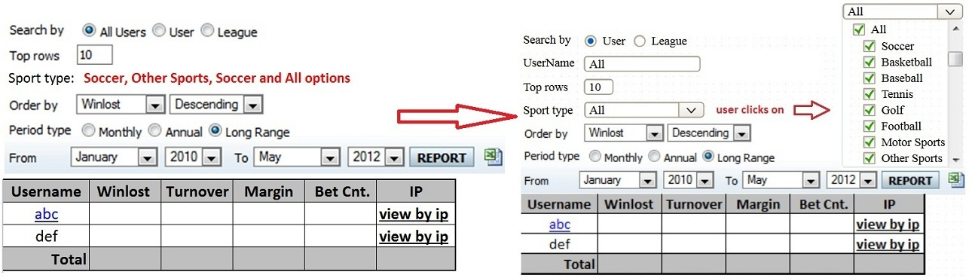
Note:
- Default value for “Sport type” is “All”. In other words, “All” is checked by default in the checkbox list
- If user’s choices are other than “All” for the “Sport type”, then update the interface as shown in the following screenshot:
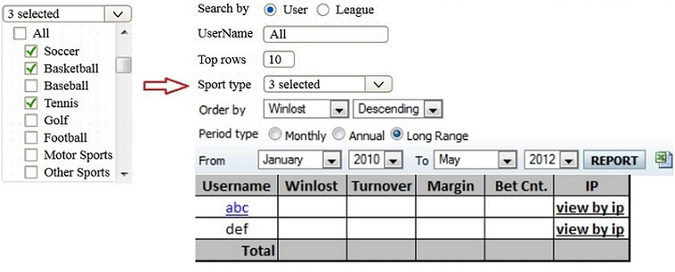
- The number of selections must be updated in real time and displayed on the dropdown list
- At least one “Sport type” is selected. Prompt a friendly message to user if selection is none.
However, the main interface will vary in accordance with the choice of user for the Search by filter.
Choice “User”:
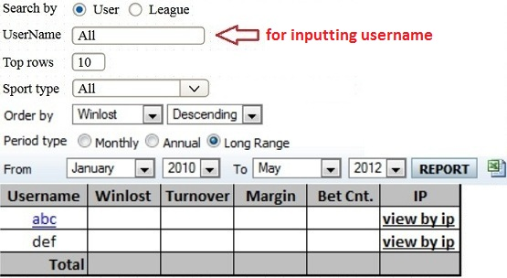
Note:
- Default behavior for “UserName” textbox is “Search by All Users”
- When the valid input of “UserName” is found in the system with the data available, show the following report page:
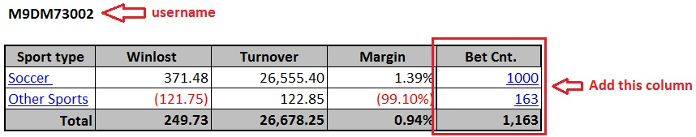

Choice “League”:
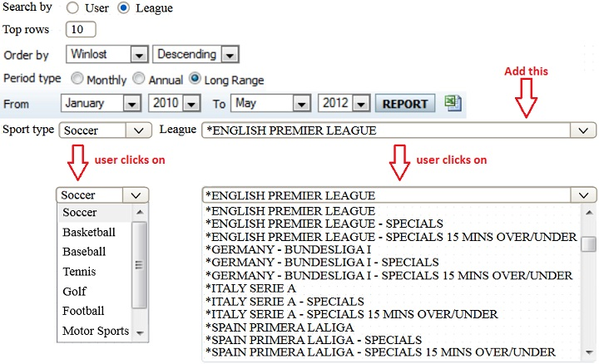
Note:
- Sport type filter is the ordinary dropdown list which means every item will have no checkbox resided before it.
- Add a new dropdown list for league selection instead of a textbox for username input.
- Default value for “Sport type” and “League” are “Soccer” and “*English Premier League” respectively.
- The data displayed in the dropdown list for league selection must match with the user’s choices for “Sport type”. For example: if the user’s choice for “Sport type” is “Golf”, then the dropdown list should show a list of “Golf League” only.

- Report Generation:
Regardless the users’ choice for the “Search by” condition, this following screenshot will be used as the layout for main generated report when users click on the “REPORT” button.
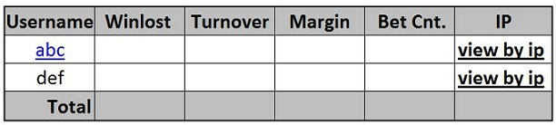
- Add an information path link (Cookie crumb) on top of each report page which not only tells users information about where they are and where they have been in this function, but also enables them to navigate back to the previous page. The link might look like the following sample screenshot:
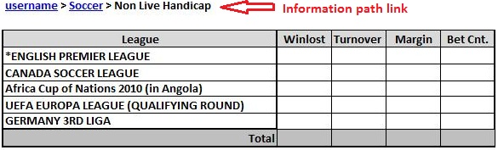
- In addition to the main report page, add the “Bet Cnt.” column to every result table as well as allocate a hyperlink to that Bet Cnt. value so that user can click on it to pursue the details of a Bet Count. For instance, the punter winlost analysis of a punter (filtered by username) will look like the screenshots shown below:
Current result table
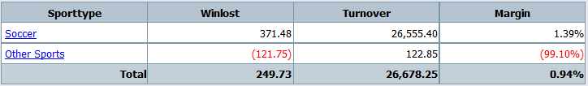
Requested result table
- Provide a new interface for a drilled-down report filtered by “username and sport type” which will contain more details about bet types as well as group them according to Non Live, Live and None Live & Live. The proposed interface is shown below:
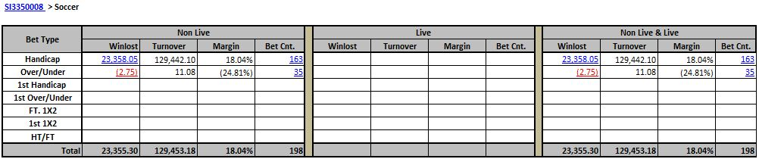
The current interface:
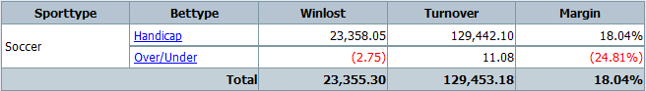
Requirements:
- Group the result (main report) according to Non Live, Live and None Live & Live type.
- Add “Bet Cnt.” column to each separating criterion Non Live, Live or None Live & Live.
- Sport type column is not needed; it’s used as the main filtering condition for the entire report instead.
- Enable user to pursue further information about the winlost amount of a bet-type by clicking on the number displayed on the winlost column (of each criterion Non Live, Live or None Live & Live) to navigate to a new report page.
Notes:
- This report page might exceed the screen size of user’s monitor horizontally and vertically. Thus, the application must facilitate a scrolling feature, whereby user will be able to scroll the report view horizontally and vertically in the way that:
  - Horizontally: column “Bet Type” remains “unmoved”
  - Vertically: Headers and sub-headers of the table remain “unmoved”
- Depends on the choice of “Period type” at the beginning of the report, the interface of the result pages would vary and it could be explained as below:
The current interface for all the cases:
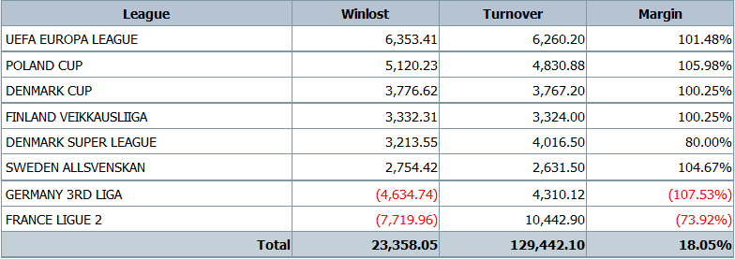

Requested interface:
- Case Monthly: Assume the month chosen is April of Year 2012
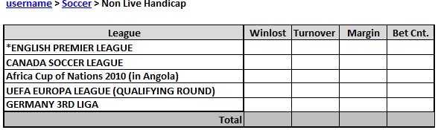
Notes: when users scroll the report view:
  - Horizontally: column “League” remains “unmoved”
  - Vertically: Header of the table remains “unmoved”

- Case Annual: Assume the year chosen is 2012
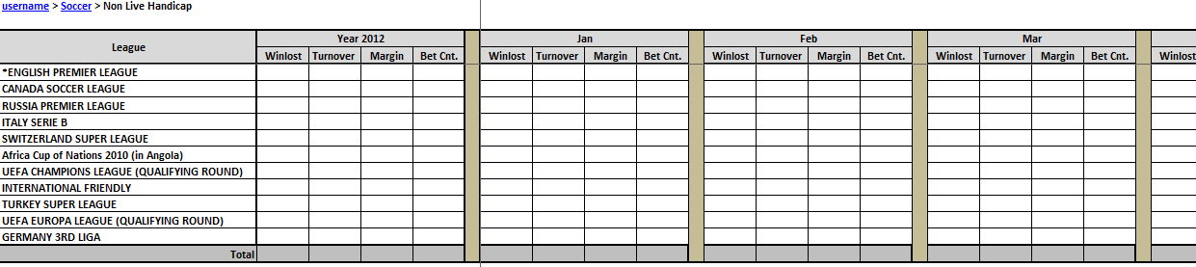
Notes:
- This report displays not only the winlost detail of year 2012, but also every single month (from Jan to Dec) of that year.
- when users scroll the report view:
  - Horizontally: The two big columns “League” and “Year 2012” remain “unmoved”
  - Vertically: Headers and sub-headers of the table remain “unmoved”
- Provide a hyperlink on any table header which is labeled with month name. When user clicks on this link, it will navigate user to the “Section 5-Case Monthly” described above.

- Case Long Range: Assume user’s choice for Period type is:
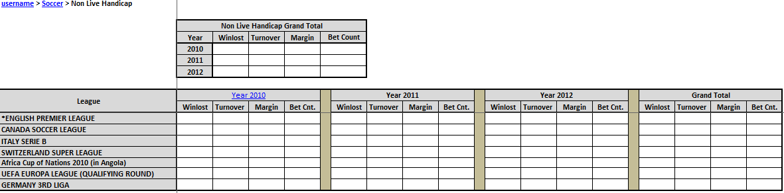

Notes:
- when users scroll the report view:
  - Horizontally: the column “League” remains “unmoved”
  - Vertically: Top level table (Non Live Handicap Grand Total), headers and sub-headers of the second level table remain “unmoved”
- Every row in the “Grand Total” table is the sum value of all the calculated years within the range of Period type of a particular league for a certain dimension (Winlost, Turnover, Margin, Bet Cnt.)
Ex: Grand Total Winlost of English Premier League from April/2010 to May/2012
= Sum Winlost of “Year 2010”, “Year 2011”, and “Year 2012” of English Premier League

- Enable user to export generated report to Excel file at any report page.

